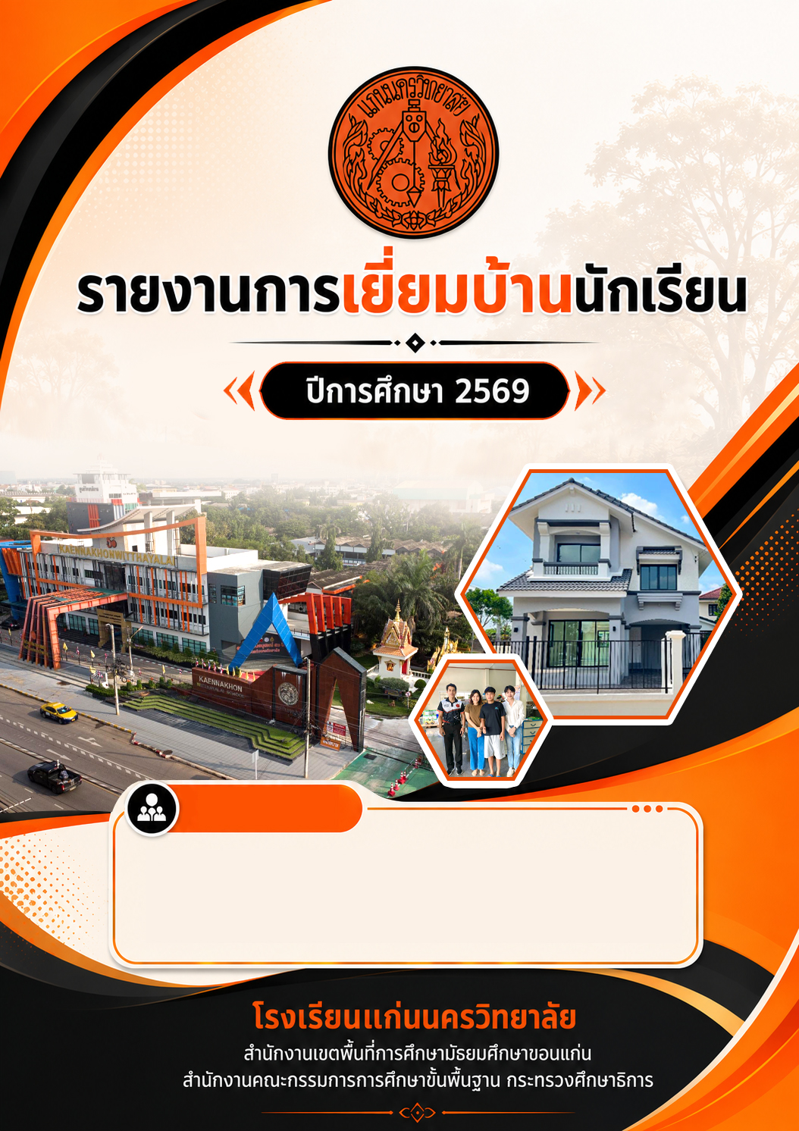
ครูที่ปรึกษาประจำชั้น ม…..
1...................................................................................................................
2...................................................................................................................
3...................................................................................................................

